Test Cases:

1. Show student Record

First Step

Click on show Data Of Student

Second step

Show Data of student

Show Academic Years:

* First Step

show subject of Academic year

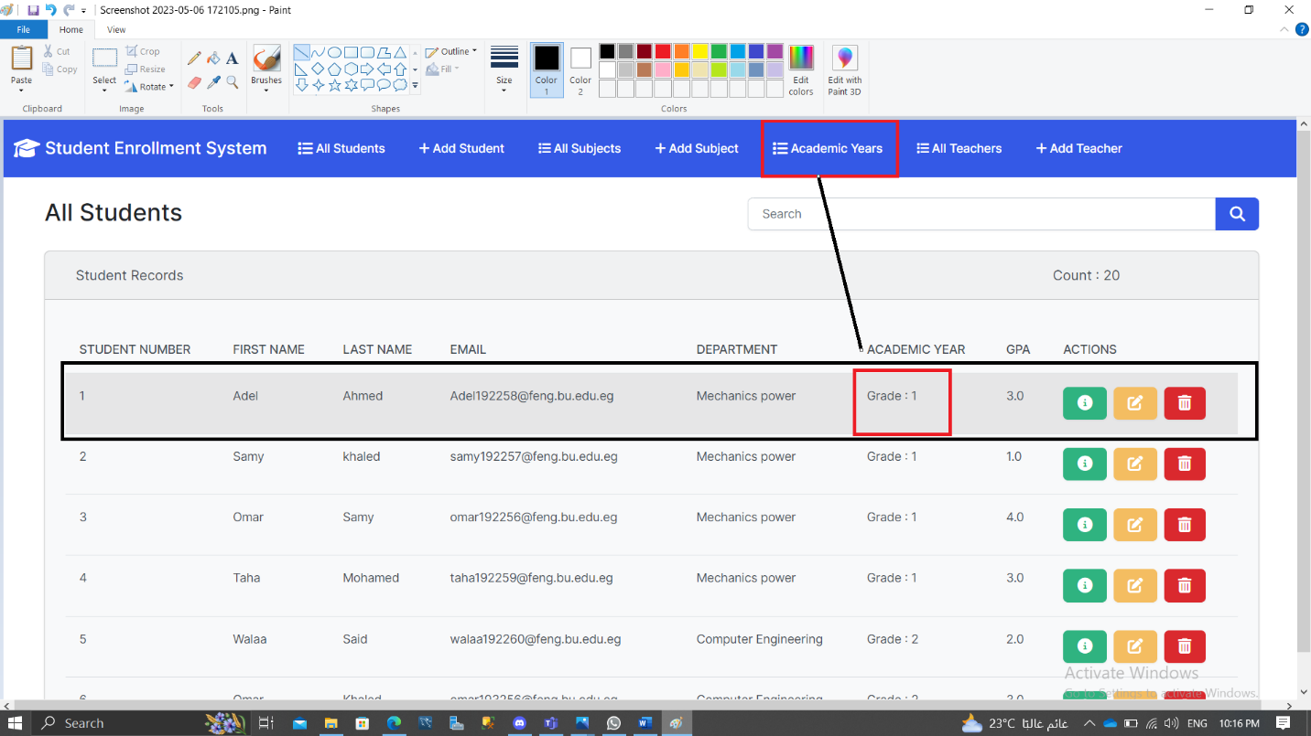

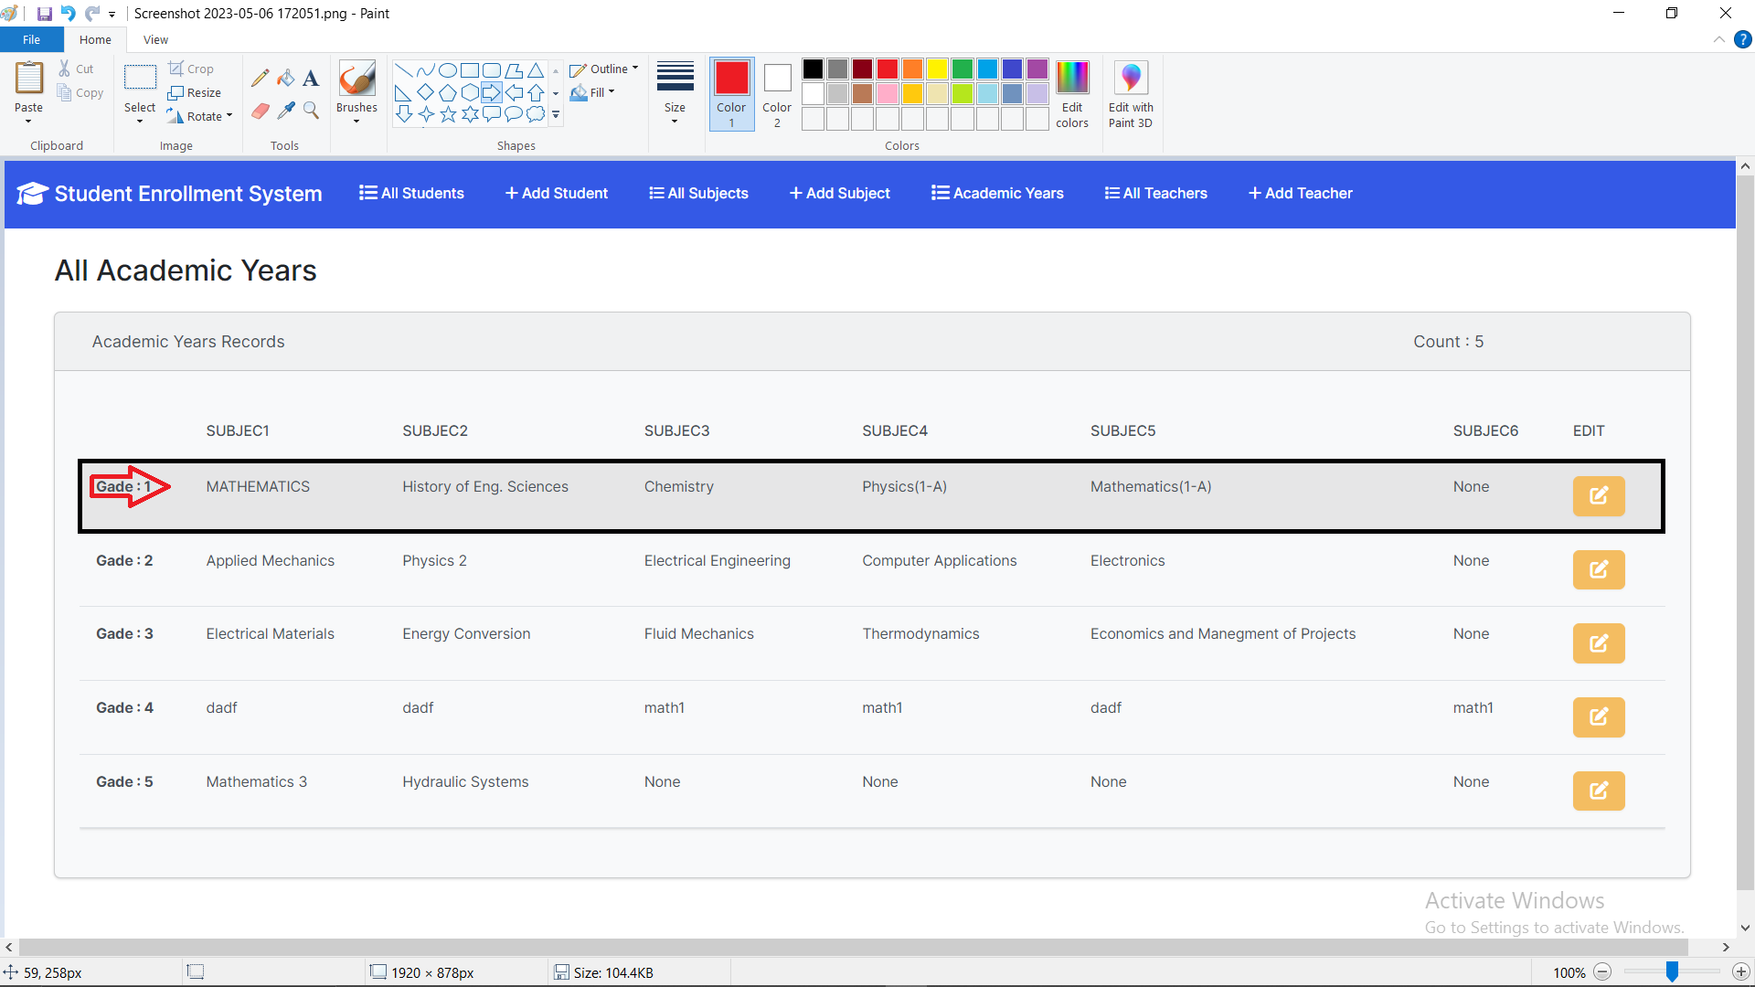

2-Search in Database

First step:-

Write in field search

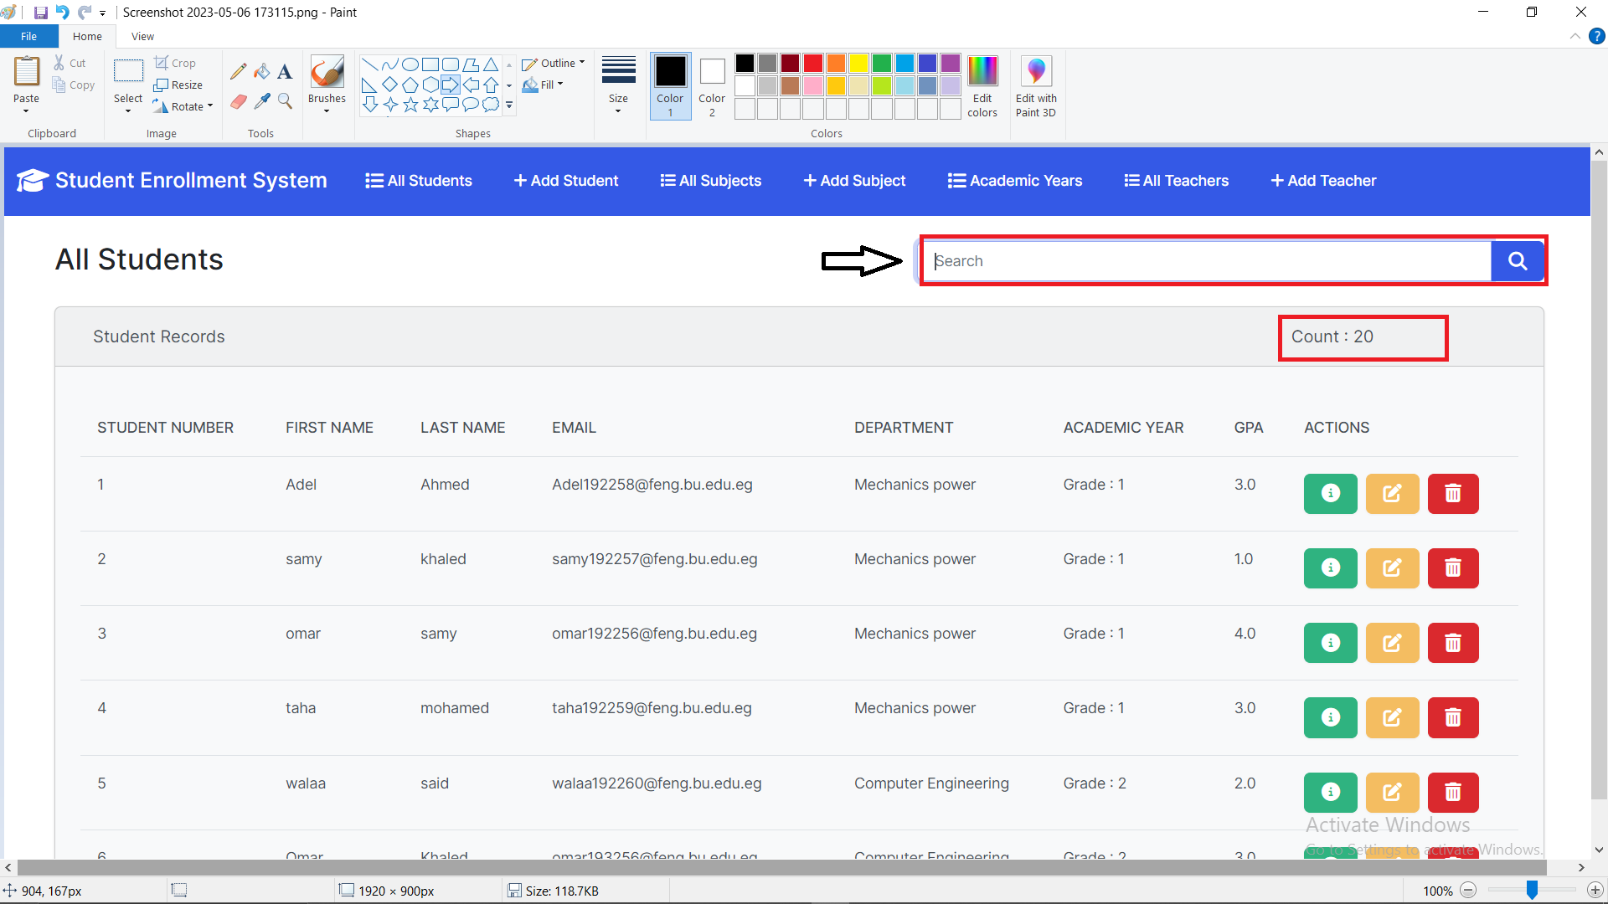

Second step:-

Search and show result

3-Edit in Database

First step:-clik on Edit Button

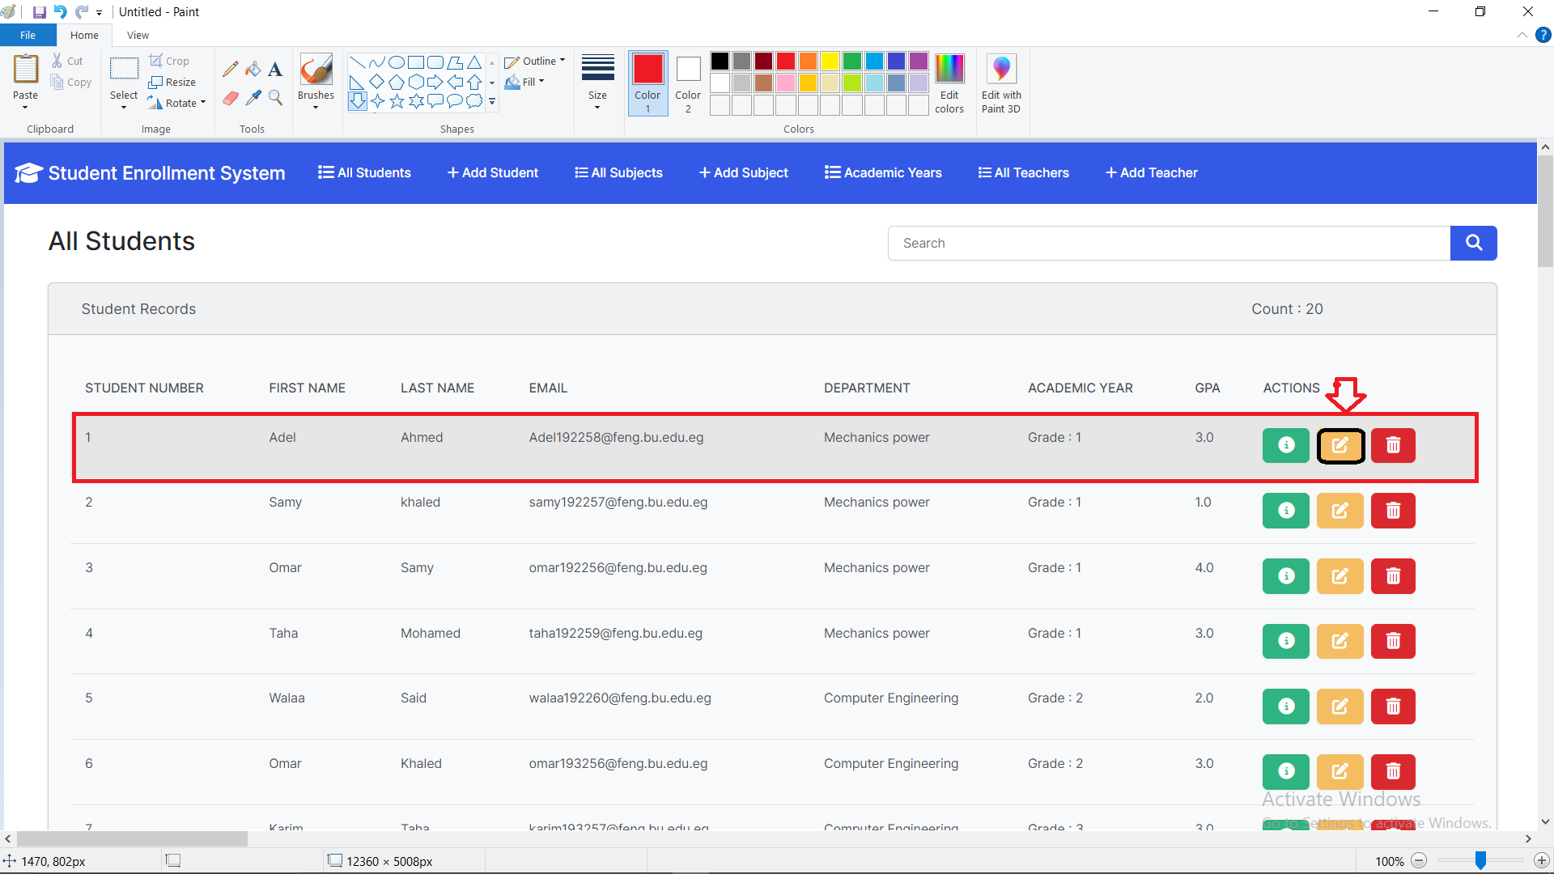

Second step:- update Data

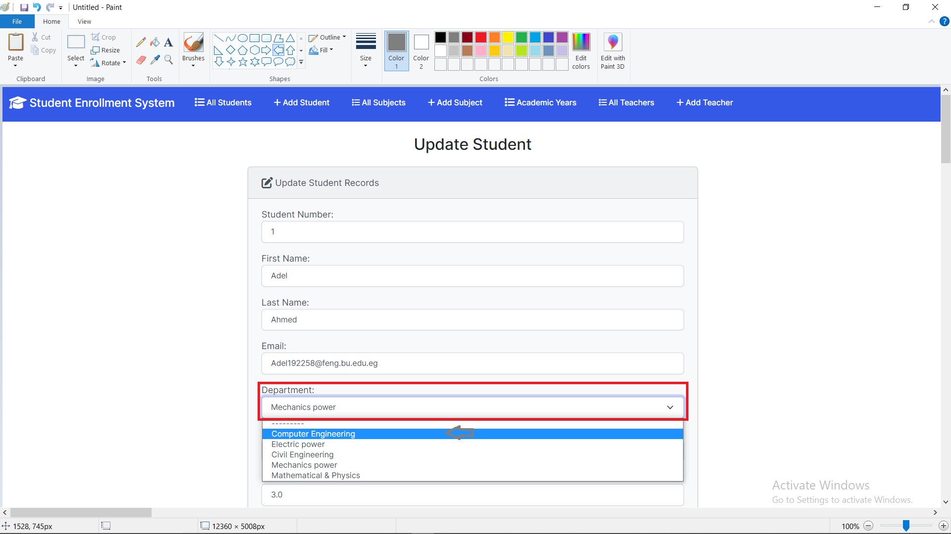

Third step After Updting:-

4-Delete in Database:-

First step:-click on delet icon

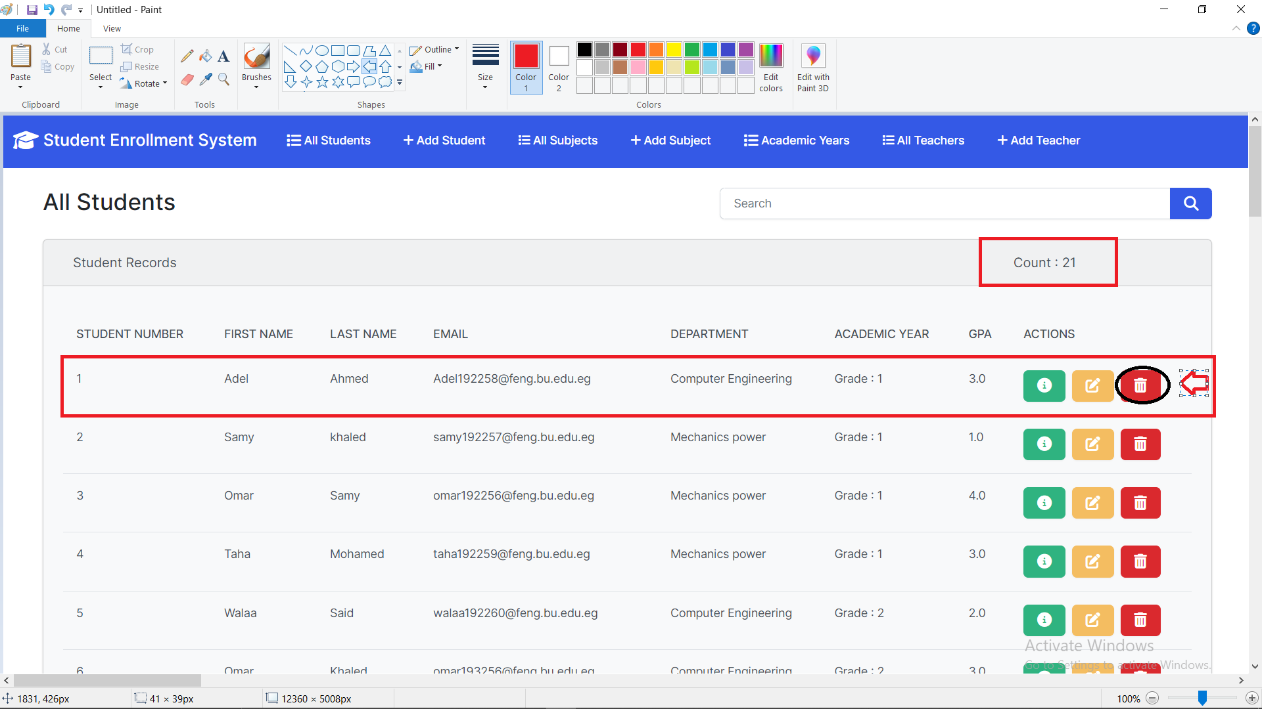

-select this record for deleting

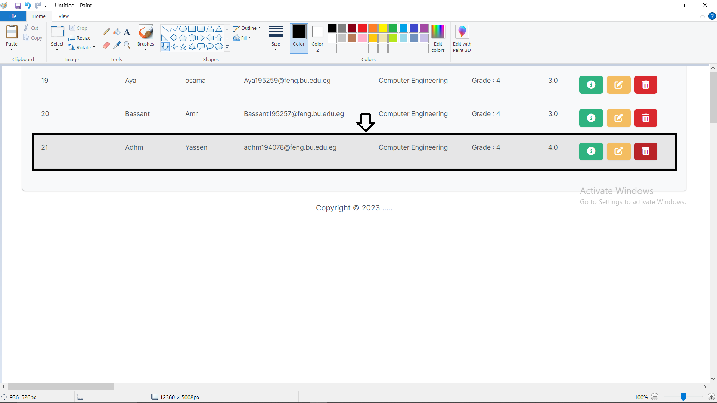

Second step:- to confirm Delet press (1)

To cancel Delet press(2)

Thrid step:After Delet record in Database

Step four :- showing in Database before Deleting

Step five:After Deleting

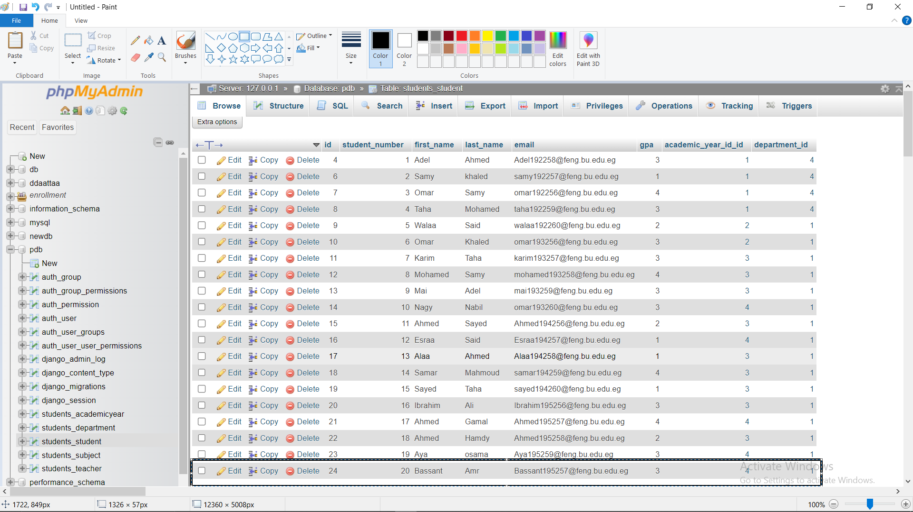

5-Show All Database

1-Show subject

2-Add subject:-

3-show All teacher

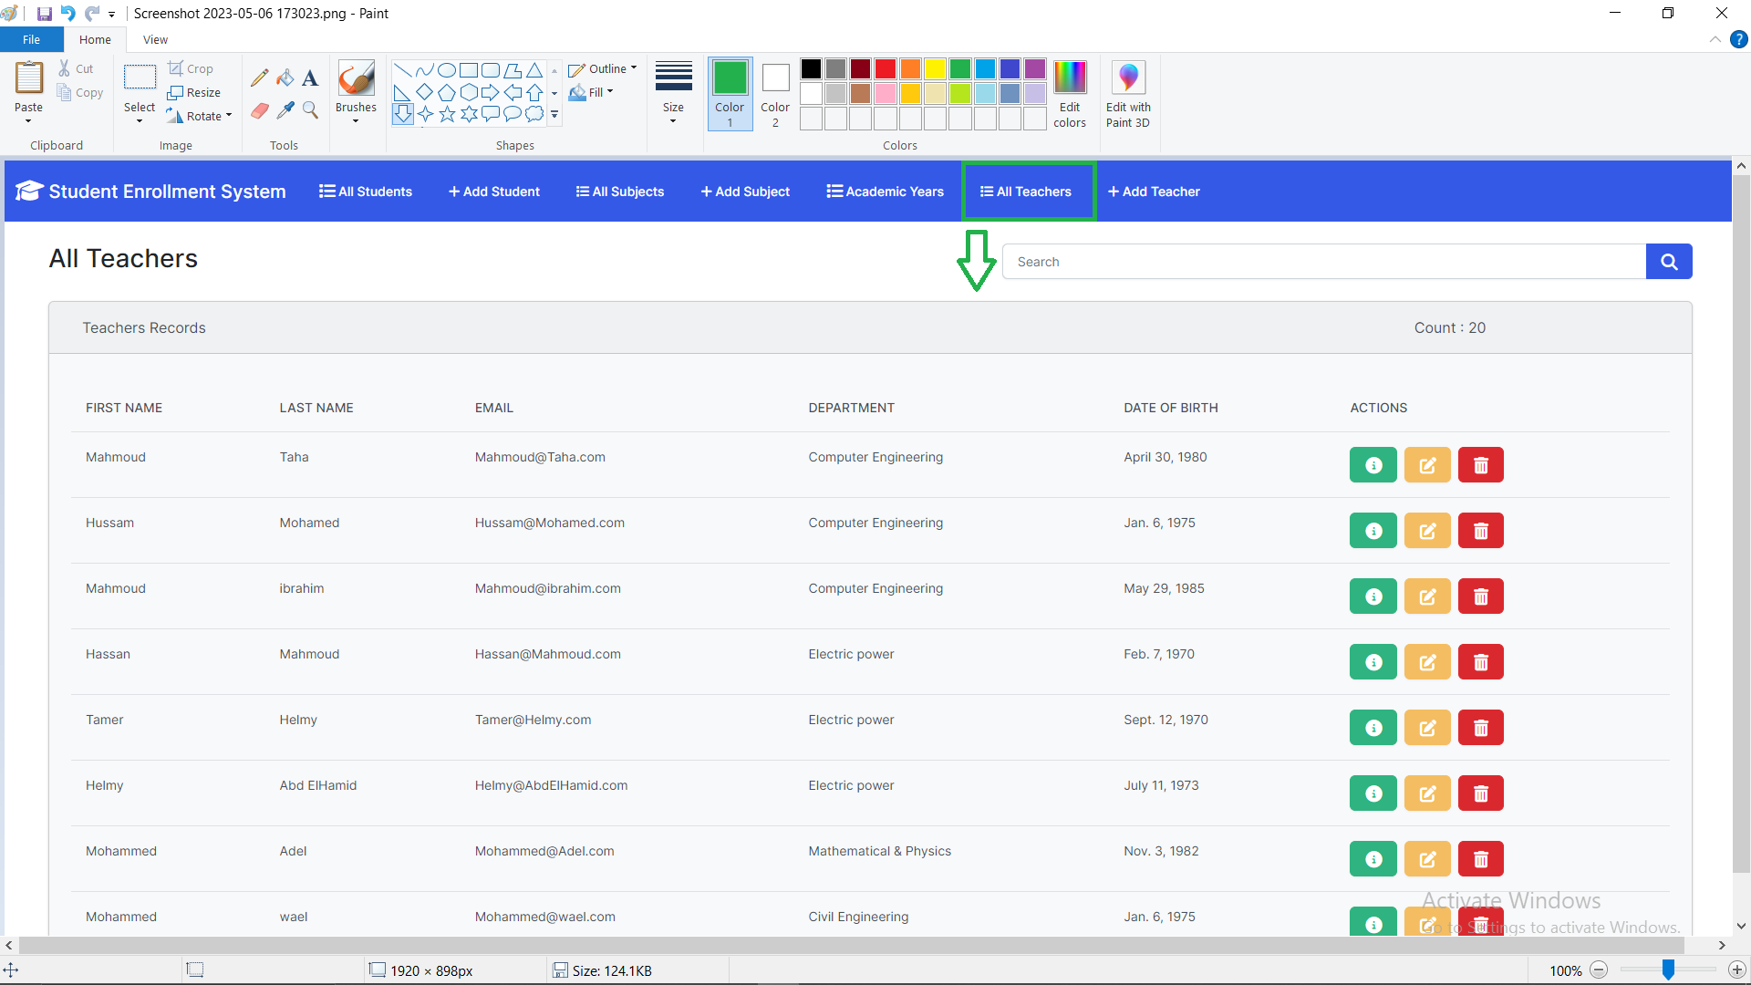

4-Add teacher

5-update Academic year

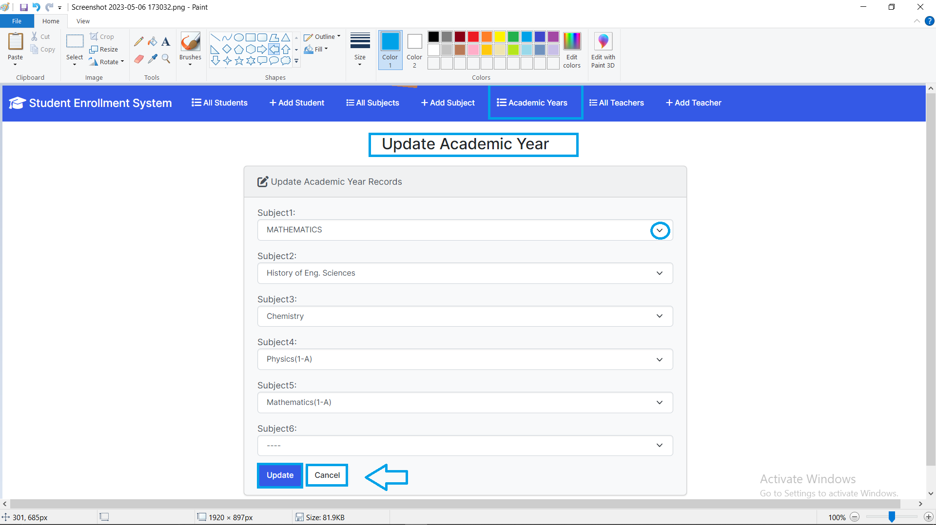

6- Add to database

1. 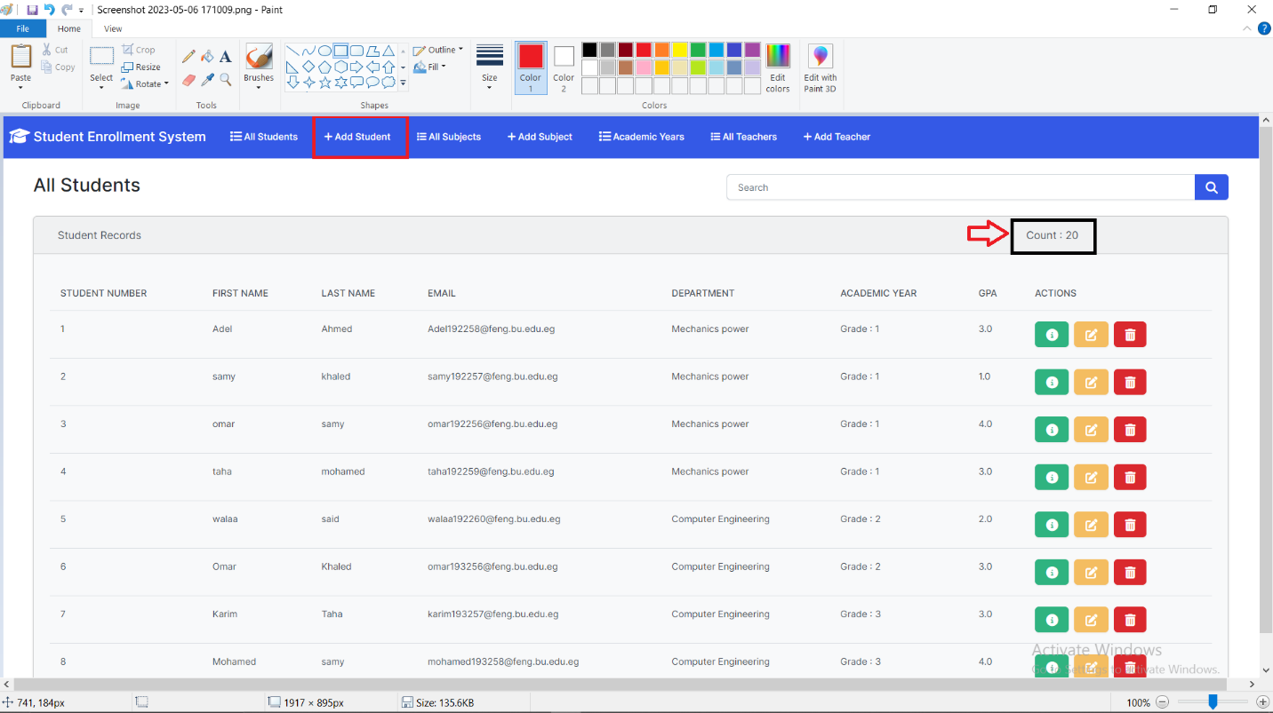Click on add student

2-Add student

3-student Add

Before Adding

After Adding:

